ECEN 361 Project Definition
  - Phreaks 4 Security
Nicholas Bastion, Joel BrAutigam, Kein Lika, James Green

Project Scope
What It Is:
This project is a smart home security system built using embedded systems technology. It combines hardware sensors, a microcontroller, and a user interface to monitor and protect residential space. The system will be capable of detecting unauthorized entry, monitoring environmental conditions, and providing real-time feedback and control to the user.
What It Will Do:
- Monitor Entry Points:
Use magnetic reed switches to detect when doors or windows are opened.
- Detect Motion:
Use PIR (Passive Infrared) sensors to detect movement within the home.
- Trigger Alerts:
Activate alarms (buzzer, LED, or notifications) when suspicious activity is detected.
- User Interaction via UI:
Provide a graphical user interface (GUI) or mobile/web dashboard where users can:
  - Arm/disarm the system.
  - View real-time sensor data.
  - Receive alerts and logs.
  - Configure system settings.
- Optional Features:
  - Environmental monitoring (e.g., temperature, smoke, gas).
  - Remote access via Wi-Fi or cloud services.
  - Battery backup or low-power operation.
Why It Is Important:
- Real-World Relevance:
Home security is a critical concern, and this project simulates a practical application of embedded systems in everyday life.
- Skill Development:
Students will gain hands-on experience with:
  - Sensor integration.
  - Microcontroller programming.
  - Communication protocols (e.g., UART, I2C, Wi-Fi).
  - UI/UX design and development.
  - System debugging and testing.
- Interdisciplinary Learning:
Combines knowledge from electronics, software engineering, networking, and human-computer interaction.
- Scalability and Innovation:
The project can be expanded with features like facial recognition, voice control, or AI-based threat detection, encouraging creativity and deeper learning.

Lessons to Learn
To successfully complete this project, the team will need to explore and understand several core concepts and technologies related to embedded systems, software development, and system integration. These include:
1. Sensor Integration and Signal Processing
- Learn how to interface various sensors (PIR, reed switches, temperature, smoke) with a microcontroller.
- Understand how to read and process digital and analog signals.
- Implement debouncing and filtering techniques to ensure reliable sensor readings.
2. Microcontroller Programming
- Gain proficiency in programming microcontrollers (e.g., ESP32, Arduino) using C/C++.
- Learn how to manage GPIO pins, interrupts, timers, and power modes.
- Implement real-time logic for monitoring and responding to sensor inputs.
3. Communication Protocols
- Learn how to use serial communication protocols such as UART, I2C, and SPI for sensor and peripheral interfacing.
- Explore wireless communication methods like Wi-Fi or Bluetooth for data transmission to the UI.
- Understand how to implement MQTT or HTTP protocols for cloud connectivity and remote access.
4. User Interface Development
- Learn how to design and build a responsive GUI using tools like:
  - Web technologies (HTML/CSS/JavaScript) for browser-based dashboards.
  - Mobile frameworks (e.g., Flutter, React Native) for app development.
  - Desktop environments (e.g., Python with Tkinter or PyQt).
- Understand how to structure UI for usability, real-time updates, and secure control.
5. Power Management
- Learn how to implement power-efficient designs using sleep modes and interrupts.
- Explore battery backup systems and energy-saving techniques for embedded devices.
6. System Integration and Testing
- Understand how to integrate hardware and software components into a cohesive system.
- Learn how to test embedded systems for reliability, responsiveness, and fault tolerance.
- Develop debugging skills using tools like serial monitors, logic analyzers, and simulation environments.
7. Security and Data Protection
- Learn basic principles of embedded system security, including:
  - Secure communication (e.g., encryption for Wi-Fi).
  - Authentication for UI access.
  - Safe handling of user data and logs.

Roles and Responsibilities
Define roles and responsibilities for each team member and report them here. Note the team leader is required, but the others are provided just as examples.
Role | Name | Responsibilities
Team Leader | Joel Brautigam | - Set up project in Monday.com and invite team  - Manage project tasks in Monday.com  - Submits group assignments  - Establishes meeting schedule (1-2 times per week)
Hardware Lead | Nicholas Bastion  James Green | - Final decision maker on hardware selection  - Hardware block diagram owner  - Gathers necessary hardware (purchase or loan)
Software Lead | Kein Lika | - Final decision maker on software architecture  - Software block diagram owner  - Set up Git repository and share with team

Schedule
Create initial set of tasks in Monday.com and assign a person and dates and durations. Export main table to Excel and Gantt chart to PDF and turn in with this sheet.

Derived Requirements
List the requirements for your project. Derived requirements are typically broken down into three categories: general, interface, and functional.

General Requirements
Form Factor
- Small, contained units.
- Sensors are individual.
- Wired connections
Power
- Runs off 120v AC.
Hardware
- Currently we want the system to run on a Raspberry Pi. For sake of our software lead.
Interface
- Some sort of applet could be web based, but it runs locally on the pi.

Interface Requirements
Interface requirements detail the interfaces of the system and cover items such as communication standards, protocols, baud/bit rates, cloud connectivity, security, etc. Use these to help guide hardware selection and software design.
Communication Protocols
- UART (9600–115200 bps): For serial communication with sensors and actuators.
- I2C (100–400 kHz): For low-speed sensor interfacing.
- SPI (up to 10 MHz): For high-speed peripherals.
- Wi-Fi (802.11 b/g/n): For wireless connectivity to cloud and UI.
Cloud & Remote Access
- Protocols: MQTT (port 1883/8883) and HTTPS (port 443).
- Platform: AWS IoT, Firebase, or similar.
- Features: Real-time data, alerts, remote control via web/mobile dashboard.
Security
- Authentication: Login required for dashboard access.
Hardware Interfaces
- GPIO: For sensor and actuator connections.
- Power: 120V AC with optional battery backup.

Functional Requirements
Functional requirements detail the features and overall functionality of the system and cover items such as specific capabilities and behaviors required to fulfill the scope of the project.
Security Monitoring
- Entry Detection: Magnetic reed switches detect door/window openings.
- Motion Detection: PIR sensors monitor movement inside the home.
- Alert System: Triggers alarms (buzzer, LED, or notifications) upon suspicious activity.
User Interaction
- Dashboard Access: Users can arm/disarm the system, view sensor data, receive alerts, and configure settings via a local web or mobile dashboard.
Environmental Monitoring (Optional)
- Sensors: Monitor temperature, smoke, and gas levels.
- Alerts: Notify users of abnormal environmental conditions.
Remote Access
- Wi-Fi/Cloud Integration: Enables system control and monitoring from remote devices.
Power Management
- Primary Power: Operates on 120V AC.
- Backup: Optional battery support for power outages.
- Efficiency: Uses sleep modes and interrupts to conserve energy.
System Reliability
- Real-Time Response: Immediate reaction to sensor inputs.
- Data Logging: Stores event logs for review.
- Testing & Debugging: Includes tools like serial monitors and logic analyzers.

Hardware Block Diagram
Create an initial, rough hardware block diagram showing the major hardware components, how they connect, how they are powered, etc. Use a professional tool such as LucidChart, draw.io, or Miro for this. Export a PDF and turn in with this sheet. Note that this is not final and will be updated weekly.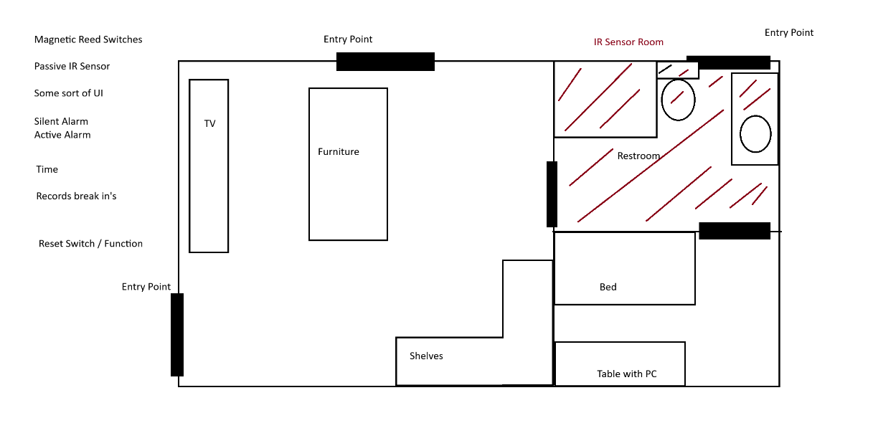
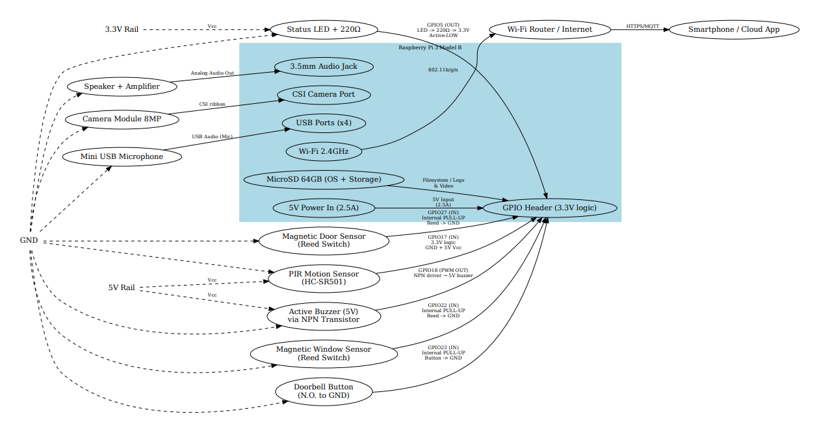

HardwareDiagram_v2.pdf

Software Block Diagram
Create an initial, rough software block diagram showing the major software modules, how they connect, how they interface with hardware, etc. Use a professional tool such as LucidChart, draw.io, or Miro for this. Export a PDF and turn in with this sheet. Note that this is not final and will be updated weekly.
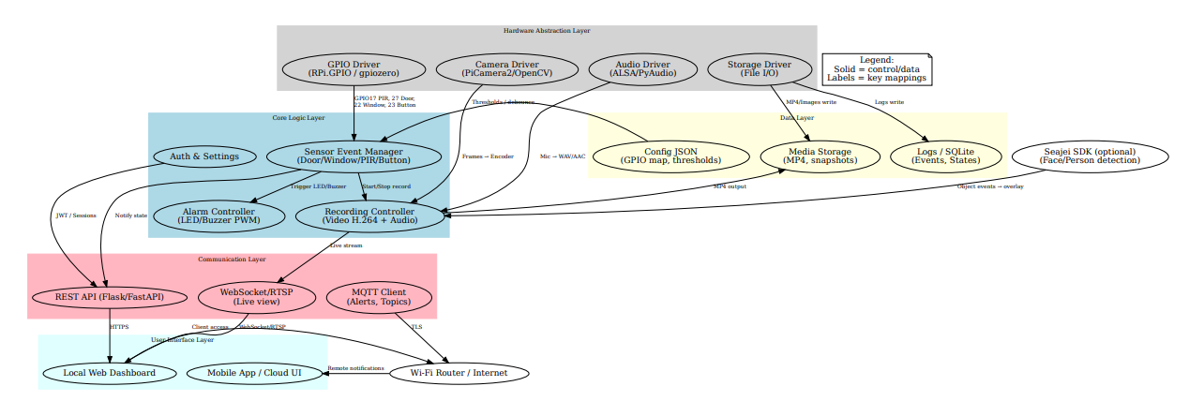
https://drive.google.com/file/d/1B9XFPiyofJJlrwn9pkn7Civo2eum8l0D/view?usp=sharing
SoftwareDiagram_v2.pdf

